Brief Review: Hematopoietic differentiation of pluripotent stem cells in vitro
Posted by Irina Elcheva on Thu, Jan 24, 2013
Pluripotent stem cells (PSCs) derived from the inner part of a blastocyst (embryonic stem cells, ESCs) or through reprogramming of terminally differentiated adult cells (induced pluripotent stem cells, iPSCs) are capable of self-renewal and differentiation into almost all cell types in the human body. Their differentiation capacities and proliferation potential make pluripotent stem cells a promising source of cells for various clinical applications including regenerative medicine.
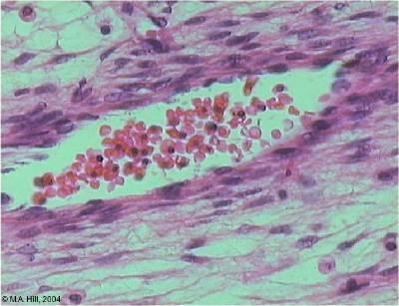Blood is considered to be a connective tissue both functionally and embryologically. It originates from the mesodermal layer, the same germ layer that give rise to the other connective tissues such as bone, cartilage and muscle. Blood cells and blood vessels develop in a parallel and form a functional circulating system. Various studies have shown, that hematopoietic differentiation of PSCs in vitro closely resembles early steps of blood development in the embryo and induces blood forming cell populations with mesodermal and hemato-endothelial properties. Different types of mature blood cells were successfully generated from murine, primate and human pluripotent stem cells. Here, we will briefly review the major in vitro systems of hematopoietic differentiation from PSCs.
Embryoid Body formation
Hematopoietic differentiation of PSCs can be carried out in either a two-dimensional system (2D), where cells are attached to the plate during differentiation, or in a three-dimensional system (3D), where isolated cells are dispersed into a liquid or a semisolid medium to form embryoid bodies (EBs).
Embryoid bodies are spherical structures that are formed by 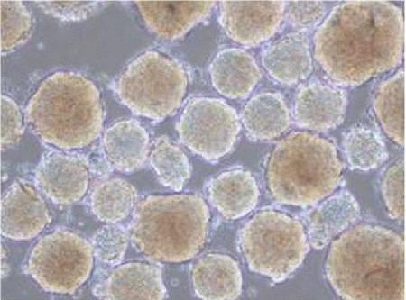pluripotent stem cells grown in non-adherent culture conditions (3D system). Differentiation of PSCs in aggregates mimics three-dimensional embryonic development and yields the establishment of cell adhesion, paracrine signaling and a microenvironment similar to native tissue structures. Thus, EB formation is often used as a method for initiating spontaneous differentiation of PSCs towards all three germ lines.
Differentiation in the presence of growth factors specific for mesoderm (BMP4, FGF, activin A) and blood formation (VEGF, SCF, Flts3, IL-3, IL-6, G-SCF, TPO) promotes hematopoiesis within embryoid aggregates and may result in the appearance of tissue-like structures such as blood islands and early blood vessels. The combination of BMP4 with hematopoietic cytokines yields up to 20% of CD34⁺CD45⁺ cells that will give rise to erythroid, macrophage, granulocytic and megakaryocytic colonies.
To produce EBs of equal size and standardize differentiation, a certain number of cells can be used to form aggregates by a spin technique (centrifugation) or in a hanging drops method. Hanging drops are single 10-20μl drops with known cell densities that are inoculated into micro-wells. Several studies have shown improvements of this method that would allow it practical application.
Coculture with stromal cells
This two-dimensional differentiation system is based on induction of hematopoiesis upon exposure to extrinsic signals from the feeder cells that underlie the PSCs in coculture. Stromal cells with the capacity to induce and support hematopoiesis can be isolated from a variety of anatomical sites associated with the hematopoietic development in vivo. A number of cell lines were established from mouse bone marrow (OP9, MS5 and S17), yolk sac endothelium (C166), fetal liver (mFLSC, EL08) and other sources. The genetically modified stromal cells, immortalized or expressing specific growth factors and signaling molecules are widely used in hematopoietic coculture.
The standard coculture conditions comprise prolonged, up to 4 weeks, incubation of undifferentiated pluripotent stem cells on top of the stromal cells in the presence of fetal bovine serum (FBS) and/or hematopoietic cytokines. Both mouse and human pluripotent cells can be successfully differentiated into CD34+ multi-lineage blood progenitors in a coculture, though the efficiency of hematopoietic differentiation significantly varies between different stromal cell lines and compositions of differentiation media.
Defined feeder-free, serum-free systems
These systems are designed to avoid the usage of undefined, animal-origin components such as FBS and stroma cells to achieve highly reproducible and efficient outputs. Thus, PSCs can be plated on matrix protein collagen IV and differentiated into primitive CD34+CD43+ hematopoietic progenitors by exposure to BMP4, bFGF and VEGF. This initial differentiation is more efficient when accompanied with the hypoxic conditions (5% oxygen tension) that resemble the environment of a developing embryo. A further incubation of blood progenitors with the various combinations of cytokines yields maturation of CD71+CD235a+ erythroid cells, CD41a+ CD42b+ megakaryocytes, HLA-DR+CD1a+ dendritic cells, CD14+CD68+ macrophages, CD45+CD117+ mast cells and CD15+CD66+ neutrophils.
Despite the great progress achieved in the in vitro modeling of hematopoiesis, blood production from PSCs is still a variable process. The final goal of intensive research in this area – a consistent production of engraftable cells, capable of reconstitution of all blood lineages in a body, remains a major challenge. Finding critical intrinsic and extrinsic factors that can recreate the unique properties of a hematopoietic stem cell niche in vitro, could advance the generation and expansion of PSCs-derived hematopoietic stem cells in the future.

